Welcome to Examplify!
*These steps should NOT be completed with a cell phone or mobile device, but rather with the device you will take exams *
- Methodist College (IL) administrators will send you an email invitation to activate your ExamSoft student account.
- Within the invitation email, you’ll be prompted to create a personal account password.
- Once you create your password and follow the prompts, you’ll be brought to the ExamSoft student portal.
- Within the portal, you can download Examplify, please ensure your device meets the minimum system requirements.

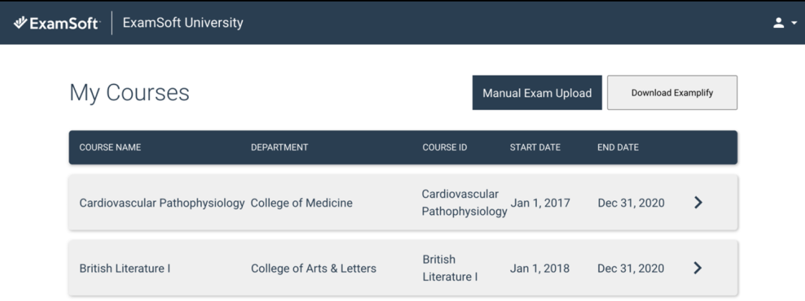

- Once the download is complete, install Examplify.
  - If you go to run the installer and it says you already have the same or a newer version of Examplify installed, you do not need to uninstall your current version
  - Open your existing installation if Examplify, go to “Home Menu” and then “Settings”
  - Go to “Clear Registration” and again click “Clear Registration” at the prompt – this will not delete any saved information that won’t come back, it only fully signs you out of Examplify
  - Examplify will close, continue on with the steps below
- After the installation is complete, launch Examplify.
- You’ll be prompted to enter your institution ID, which is methodistcol (IL) – Do not use the old Methodist College link if its still in there, it will try and take you to the old sign in which no longer works. This should go away before long but since this is new, there are some changes that take time to go through. Only click the option circled below:
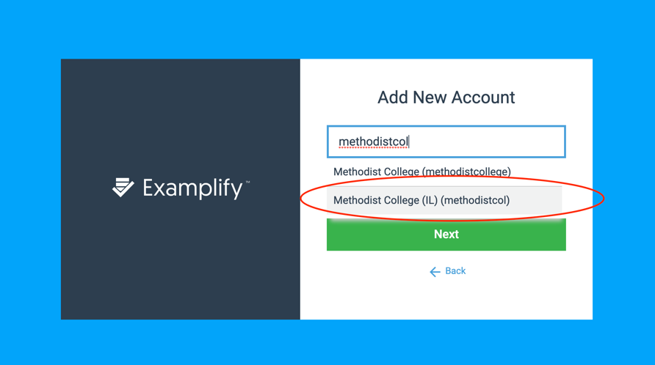
- Next, enter your student ID and the password you set up for your account.
- Once your credentials are entered, select Sign In.
- Congratulations, you can now use Examplify for testing!

